Eyeconic - Glasses Shop Management System

Order (User)

Version 1.0

Revision History

|  |  |  |  |
| --- | --- | --- | --- |
| **Date** | **Version** | **Description** | **Author** |
| 26/11/2019 | 1.0 | The first version of add order | Hoàng Tiến Long |

Table of Contents

1. Introduction 4

1.1 Purpose 4

1.2 Scope 4

1.3 Definitions, Acronyms, and Abbreviations 4

1.4 References 4

1.5 Overview 4

2. Flow of Events—Design 4

3. Derived Requirements 6

# Introduction

## Purpose

This document describes how the Add Order use case is realized within the design model.

## Scope

This document applies to the Eyeconic - Glasses Shop Management System.

## Definitions, Acronyms, and Abbreviations

None.

## References

None.

## Overview

In the following section, Use-Case Realization Specification of the Add Order use-case of the Eyeconic is provided in detail. The first section is a textual description of the Use-Case specification. The following section contains sequence diagrams describing how the use case is realized in terms of collaborating objects. The third section includes class diagrams with relationships that participate in the realization of the use case. The last section is an analysis of all requirements, such as non-functional requirements, on the use-case realization that are not considered in the design model, but that need to be taken care of during implementation.

# Flow of Events—Design

**2.1. Use-Case Specification**

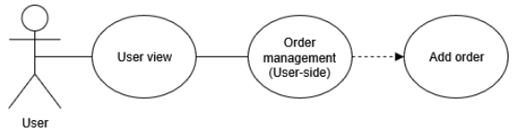

|  |  |  |  |
| --- | --- | --- | --- |
| **Name** | | | Add Order |
| **Brief Dexcription** | | | User selects product and adds new orders into the website. |
| **Actors** | | | User |
| **Flow of Events** | | | |
| **Basic Flow** | | | |
| Step 1: Click add a new order button in product view.  Step 2: Enter information into new order’s form.  Step 3: Set the database parameters of new order.  Step 4: System displays new order in the user order-view. | | | |
| **Alternative Flows** | | | |
| **Title** | | **Description** | |
| Invalid information entered | | 1. User enters invalid information in order’s form.  2. System displays information with appropriate message to correct invalid information. | |
| **Pre-Conditions** | | | |
| The added order had not existed in the database before. | | | |
| **Post-Condition**  User checks the order view page and the website to ensure that the new order is added successfully. | | | |
| **Title** | **Description** | | |
| Success | Success message is prompted and the order is added to website. | | |
| Failure | The user is unable to add new order to website for one or more reasons and an error is prompt. | | |
| **Extension Points** | None | | |

**2.2. Sequence Diagram**

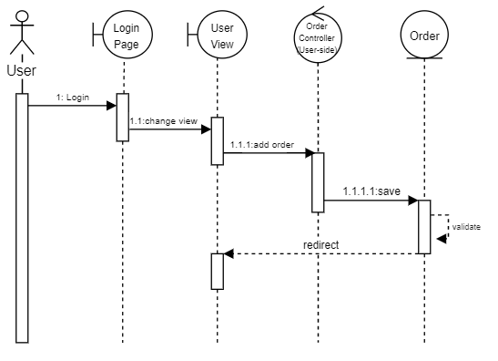

**2.3. Class Diagram**

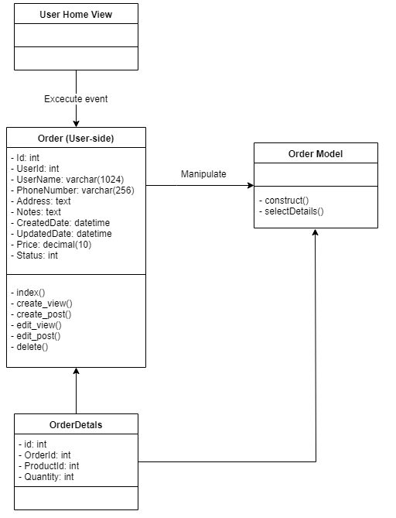

# Derived Requirements

None.